Figure 1 0.05

RiseTime: 0.3701

SettlingTime: 0.6643

SettlingMin: 38.9355

SettlingMax: 43.2422

Overshoot: 0

Undershoot: 0

Peak: 43.2422

PeakTime: 1.0520

Figure 2 0.1

RiseTime: 0.1625

SettlingTime: 0.2818

SettlingMin: 39.9023

SettlingMax: 44.2969

Overshoot: 0

Undershoot: 0

Peak: 44.2969

PeakTime: 0.5120

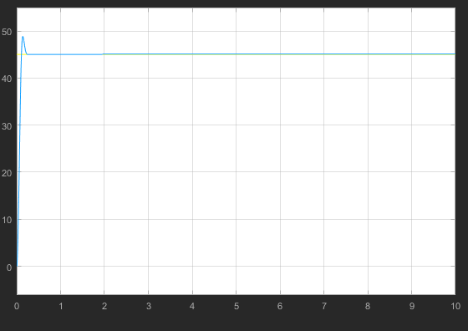

Figure 3 0.3

RiseTime: 0.0712

SettlingTime: 0.1955

SettlingMin: 40.9570

SettlingMax: 48.8672

Overshoot: 8.3821

Undershoot: 0

Peak: 48.8672

PeakTime: 0.1380

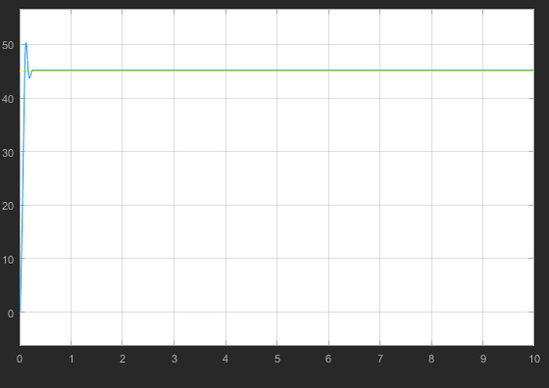

Figure 4 0.6

RiseTime: 0.0684

SettlingTime: 0.2134

SettlingMin: 40.9570

SettlingMax: 50.3613

Overshoot: 11.4786

Undershoot: 0

Peak: 50.3613

PeakTime: 0.1240

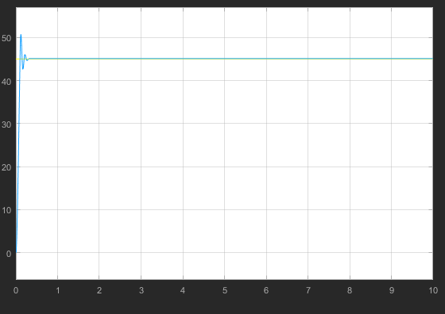

Figure 5 1

RiseTime: 0.0681

SettlingTime: 0.2215

SettlingMin: 40.7813

SettlingMax: 50.7129

Overshoot: 12.4756

Undershoot: 0

Peak: 50.7129

PeakTime: 0.1180

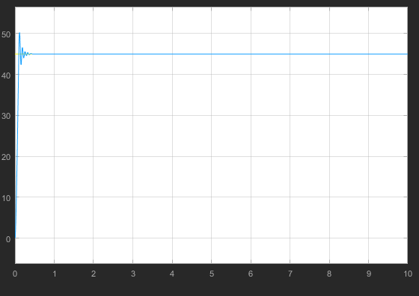

Figure 6 2

RiseTime: 0.0683

SettlingTime: 0.2255

SettlingMin: 41.2207

SettlingMax: 50.2734

Overshoot: 11.7188

Undershoot: 0

Peak: 50.2734

PeakTime: 0.1140

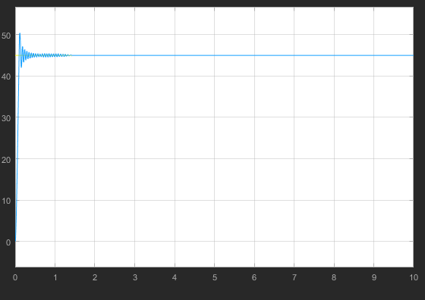

Figure 7 3

RiseTime: 0.0682

SettlingTime: 0.2975

SettlingMin: 41.0449

SettlingMax: 50.4492

Overshoot: 12.1094

Undershoot: 0

Peak: 50.4492

PeakTime: 0.1160

Figure 8 8

RiseTime: 0.0696

SettlingTime: 9.9926

SettlingMin: 41.8359

SettlingMax: 50.7129

Overshoot: 9.2803

Undershoot: 0

Peak: 50.7129

PeakTime: 0.1160

Figure 0.05 PD

RiseTime: 1.2256

SettlingTime: 1.9860

SettlingMin: 39.5508

SettlingMax: 44.0332

Overshoot: 0

Undershoot: 0

Peak: 44.0332

PeakTime: 2.4500

RiseTime: 2.3562

SettlingTime: 9.7822

SettlingMin: 38.9355

SettlingMax: 44.4727

Overshoot: 2.0161

Undershoot: 0

Peak: 44.4727

PeakTime: 9.7160

RiseTime: 3.8732

SettlingTime: 9.2632

SettlingMin: 39.7266

SettlingMax: 45

Overshoot: 0.5894

Undershoot: 0

Peak: 45

PeakTime: 9.8160

RiseTime: 4.6705

SettlingTime: 9.9957

SettlingMin: 12.7441

SettlingMax: 18.4570

Overshoot: 27.2727

Undershoot: 3.6364

Peak: 18.4570

PeakTime: 8.4500

RiseTime: 0.3776

SettlingTime: 9.9802

SettlingMin: -0.0879

SettlingMax: 94.9219

Overshoot: 634.6939

Undershoot: 2.7211

Peak: 94.9219

PeakTime: 4.3320

RiseTime: 8.4517

SettlingTime: 9.8048

SettlingMin: 77.6953

SettlingMax: 87.0117

Overshoot: 0.3040

Undershoot: 0

Peak: 87.0117

PeakTime: 9.9720

RiseTime: 8.0843

SettlingTime: 9.9451

SettlingMin: 48.9551

SettlingMax: 54.7559

Overshoot: 0

Undershoot: 0

Peak: 54.7559

PeakTime: 10

RiseTime: 0.3596

SettlingTime: 5.1034

SettlingMin: 36.5625

SettlingMax: 66.5332

Overshoot: 46.7054

Undershoot: 0

Peak: 66.5332

PeakTime: 0.9220

RiseTime: 0.2563

SettlingTime: 5.0975

SettlingMin: 31.0254

SettlingMax: 71.4551

Overshoot: 58.7891

Undershoot: 0

Peak: 71.4551

PeakTime: 0.6860

RiseTime: 0.2611

SettlingTime: 9.8755

SettlingMin: 19.2480

SettlingMax: 79.6289

Overshoot: 76.9531

Undershoot: 0

Peak: 79.6289

PeakTime: 0.7280

RiseTime: 0.2590

SettlingTime: 3.1955

SettlingMin: 39.9023

SettlingMax: 62.7539

Overshoot: 39.4531

Undershoot: 0

Peak: 62.7539

PeakTime: 0.6620

RiseTime: 0.2127

SettlingTime: 1.2853

SettlingMin: 41.0449

SettlingMax: 53.9648

Overshoot: 18.7621

Undershoot: 0

Peak: 53.9648

PeakTime: 0.5600

RiseTime: 0.0786

SettlingTime: 1.2535

SettlingMin: 40.5176

SettlingMax: 46.3184

Overshoot: 2.9297

Undershoot: 0

Peak: 46.3184

PeakTime: 0.2300

RiseTime: 0.0688

SettlingTime: 0.1054

SettlingMin: 41.2207

SettlingMax: 45

Overshoot: 0

Undershoot: 0

Peak: 45

PeakTime: 0.1240

RiseTime: 0.0589

SettlingTime: 8.1910

SettlingMin: -77.8711

SettlingMax: 77.4316

Overshoot: 72.0703

Undershoot: 173.0469

Peak: 77.8711

PeakTime: 5.2880